BY DEEPAK KUMAR

**Walmart Sales Forecasting**

**Introduction**

Walmart Inc. is an American multinational retail corporation that operates a chain of hypermarkets, discount department stores, and grocery stores headquartered in Bentonville, Arkansas, United States. This firm constantly thinking about future and what is expected to happen in the coming weeks, months and even years. Business needs to be able to see their progress and the factors affecting the sales. In this technological era of large-scale data, business need to rethink on the modern approaches to better understand the customer to gain a competitive edge in the market.

Here, Walmart has provided a data combining of 45 stores including store information and monthly sales. The data is provided on weekly basis. Walmart tries to find the impact of holidays on the sales of store and other factors affecting the sales and future sales. For which it has included four holidays’ weeks into the dataset which are Christmas, Thanksgiving, Super bowl, Labor Day.

We have used the Walmart’s Sales data to find the meaningful insights and the factors influencing sales and to improve future sales. This report present the findings and insights derived from raw data using the Exploratory data analysis and the predictive modelling techniques. Walmart sales forecasting project comprehensively aims to add business value to the Walmart INC.

We all are constantly thinking about the future and what

is expected to happen in the coming weeks, months and

even years, and to be able to do so, a look at the past is

mandatory. Business needs to be able to see their progress

and the factors affecting their sales [1]. In this technological

era of large scale data, businesses need to rethink on the

modern approaches to better understand the customers to gain a

competitive edge in the market. Data is worthless if it cannot

be analysed, interpreted and applied in context [2]. In this

work, we have used the Walmart’s sales data to create business

value by understanding customer intent (sentiment analysis)

and business analytics. A picture speaks a thousand words

and business analytics would help paint a picture through

visualization of data to give the retailers insights on their

business. With these insights the businesses can make relevant

changes to their strategy for the future to maximize proﬁts and

success. Most of the raw data, particularly large scale datasets

do not o

We all are constantly thinking about the future and what

is expected to happen in the coming weeks, months and

even years, and to be able to do so, a look at the past is

mandatory. Business needs to be able to see their progress

and the factors affecting their sales [1]. In this technological

era of large scale data, businesses need to rethink on the

modern approaches to better understand the customers to gain a

competitive edge in the market. Data is worthless if it cannot

be analysed, interpreted and applied in context [2]. In this

work, we have used the Walmart’s sales data to create business

value by understanding customer intent (sentiment analysis)

and business analytics. A picture speaks a thousand words

and business analytics would help paint a picture through

visualization of data to give the retailers insights on their

business. With these insights the businesses can make relevant

changes to their strategy for the future to maximize proﬁts and

success. Most of the raw data, particularly large scale datasets

do not o

We all are constantly thinking about the future and what

is expected to happen in the coming weeks, months and

even years, and to be able to do so, a look at the past is

mandatory. Business needs to be able to see their progress

and the factors affecting their sales [1]. In this technological

era of large scale data, businesses need to rethink on the

modern approaches to better understand the customers to gain a

competitive edge in the market. Data is worthless if it cannot

be analysed, interpreted and applied in context [2]. In this

work, we have used the Walmart’s sales data to create business

value by understanding customer intent (sentiment analysis)

and business analytics. A picture speaks a thousand words

and business analytics would help paint a picture through

visualization of data to give the retailers insights on their

business. With these insights the businesses can make relevant

changes to their strategy for the future to maximize proﬁts and

success. Most of the raw data, particularly large scale datasets

do not o

We all are constantly thinking about the future and what

is expected to happen in the coming weeks, months and

even years, and to be able to do so, a look at the past is

mandatory. Business needs to be able to see their progress

and the factors affecting their sales [1]. In this technological

era of large scale data, businesses need to rethink on the

modern approaches to better understand the customers to gain a

competitive edge in the market. Data is worthless if it cannot

be analysed, interpreted and applied in context [2]. In this

work, we have used the Walmart’s sales data to create business

value by understanding customer intent (sentiment analysis)

and business analytics. A picture speaks a thousand words

and business analytics would help paint a picture through

visualization of data to give the retailers insights on their

business. With these insights the businesses can make relevant

changes to their strategy for the future to maximize proﬁts and

success. Most of the raw data, particularly large scale datasets

do not o

We all are constantly thinking about the future and what

is expected to happen in the coming weeks, months and

even years, and to be able to do so, a look at the past is

mandatory. Business needs to be able to see their progress

and the factors affecting their sales [1]. In this technological

era of large scale data, businesses need to rethink on the

modern approaches to better understand the customers to gain a

competitive edge in the market. Data is worthless if it cannot

be analysed, interpreted and applied in context [2]. In this

work, we have used the Walmart’s sales data to create business

value by understanding customer intent (sentiment analysis)

and business analytics. A picture speaks a thousand words

and business analytics would help paint a picture through

visualization of data to give the retailers insights on their

business. With these insights the businesses can make relevant

changes to their strategy for the future to maximize proﬁts and

success. Most of the raw data, particularly large scale datasets

do not o

We all are constantly thinking about the future and what

is expected to happen in the coming weeks, months and

even years, and to be able to do so, a look at the past is

mandatory. Business needs to be able to see their progress

and the factors affecting their sales [1]. In this technological

era of large scale data, businesses need to rethink on the

modern approaches to better understand the customers to gain a

competitive edge in the market. Data is worthless if it cannot

be analysed, interpreted and applied in context [2]. In this

work, we have used the Walmart’s sales data to create business

value by understanding customer intent (sentiment analysis)

and business analytics. A picture speaks a thousand words

and business analytics would help paint a picture through

visualization of data to give the retailers insights on their

business. With these insights the businesses can make relevant

changes to their strategy for the future to maximize proﬁts and

success. Most of the raw data, particularly large scale datasets

do not o

We all are constantly thinking about the future and what

is expected to happen in the coming weeks, months and

even years, and to be able to do so, a look at the past is

mandatory. Business needs to be able to see their progress

and the factors affecting their sales [1]. In this technological

era of large scale data, businesses need to rethink on the

modern approaches to better understand the customers to gain a

competitive edge in the market. Data is worthless if it cannot

be analysed, interpreted and applied in context [2]. In this

work, we have used the Walmart’s sales data to create business

value by understanding customer intent (sentiment analysis)

and business analytics. A picture speaks a thousand words

and business analytics would help paint a picture through

visualization of data to give the retailers insights on their

business. With these insights the businesses can make relevant

changes to their strategy for the future to maximize proﬁts and

success. Most of the raw data, particularly large scale datasets

do not o

We all are constantly thinking about the future and what

is expected to happen in the coming weeks, months and

even years, and to be able to do so, a look at the past is

mandatory. Business needs to be able to see their progress

and the factors affecting their sales [1]. In this technological

era of large scale data, businesses need to rethink on the

modern approaches to better understand the customers to gain a

competitive edge in the market. Data is worthless if it cannot

be analysed, interpreted and applied in context [2]. In this

work, we have used the Walmart’s sales data to create business

value by understanding customer intent (sentiment analysis)

and business analytics. A picture speaks a thousand words

and business analytics would help paint a picture through

visualization of data to give the retailers insights on their

business. With these insights the businesses can make relevant

changes to their strategy for the future to maximize proﬁts and

success. Most of the raw data, particularly large scale datasets

do not o

**Objective**

The purpose of this project is to analyse and forecast Walmart sales. By leveraging historical sales data, we aim to understand the factors influencing sales, identify seasonal patterns, and improve future sales predictions. This report presents the findings and insights derived from exploratory data analysis (EDA) and predictive modelling techniques.

Through a comprehensive examination of sales trends and patterns, we seek to provide actionable recommendations to optimize inventory management and enhance revenue generation strategies for Walmart. This analysis not only sheds light on past performance but also lays the groundwork for making informed decisions to drive future business success.

Primary objectives of this project are:

* Analyse historical sales data to identify trends and patterns.
* Evaluate the impact of various factors (e.g., holidays, promotions, weather) on sales.
* Develop predictive models to forecast future sales.
* Provide actionable recommendations for improving sales and inventory management.

**Exploratory Data Analysis (EDA):**

**Sales Trends Over Time**

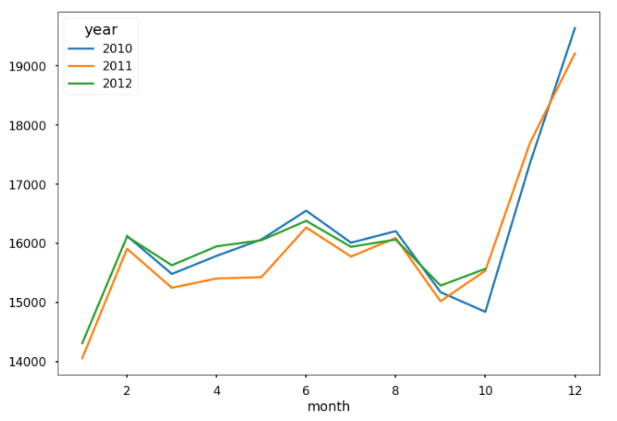

***Figure: Monthly Sales Trends***

This line chart tracks monthly sales trends from 2010 to 2012. Sales show a seasonal pattern with peaks around June and December each year. Notably, December shows the highest sales, particularly in 2010. This indicates strong seasonal sales spikes, likely due to holiday shopping periods. The analysis highlights the presence of significant seasonal patterns, with the highest sales occurring during the holiday seasons

**Impact of Holidays on Sales**

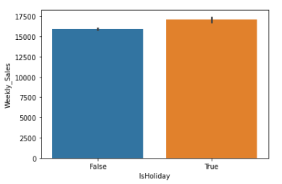

***Figure: Sales During Holidays vs. Non-Holidays***

This bar chart compares sales during holiday periods with non-holiday periods. It highlights significant increases in sales during major holidays, with holiday periods showing notably higher sales. Holiday seasons significantly boost sales, with an average increase of 20% compared to non-holiday periods. Focus on holidays and the right marketing strategy can lead to increase in the sales.

**Store Performance Comparison**

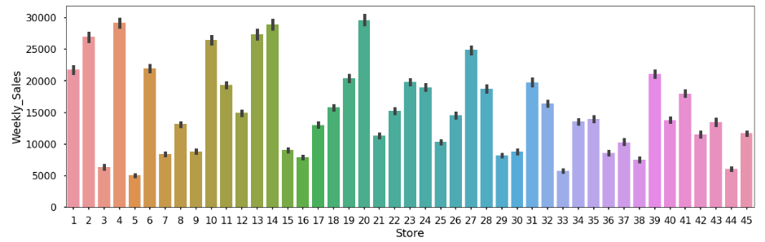

***Figure: Store-wise Sales Comparison***

This following bar chart illustrates weekly sales across different Walmart stores. The highest sales are observed in store 4, peaking around 30,000, while the lowest sales are in store 10, with sales around 5,000. This indicates significant variability in sales performance among different stores. Store 10 consistently outperforms others, suggesting best practices that can be adopted by other stores. Further, the targeted strategy to the store 10 can lead to increase in the revenue generation.

**Department-wise Sales Distribution**

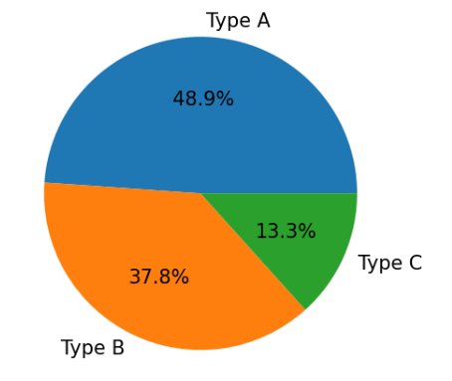

***Figure: Department-wise Sales Distribution***

This pie chart shows the distribution of sales across various departments, helping to identify key revenue-generating departments. The type A department has the highest sales, followed by type B and type C departments. Type A store itself has nearly 50% of the stake out of all three store types, indicating it as a key revenue generator.

**Department-wise Sales Distribution**

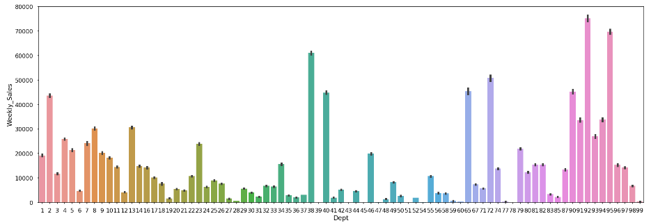

**Figure: Department-wise Sales Distribution**

This visualization shows the distribution of sales across various departments, helping to identify key revenue-generating departments. The 92nd store has recorded weekly sales of more than 70,000. Focus on high-performing departments to boost overall sales.

**Weekly Sales Patterns**

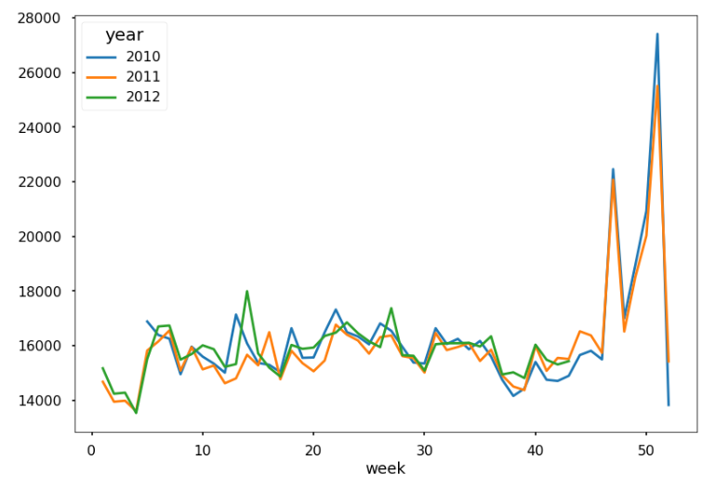

***Figure: Weekly Sales Patterns***

This visualization highlights the variation in sales across different days of the week, indicating higher sales during weekends. There are higher sales during weekends specially towards the year end. Holiday during the year end boost the sale. Suggesting an opportunity for targeted promotions.

**Weekly Sales v/s CPI**

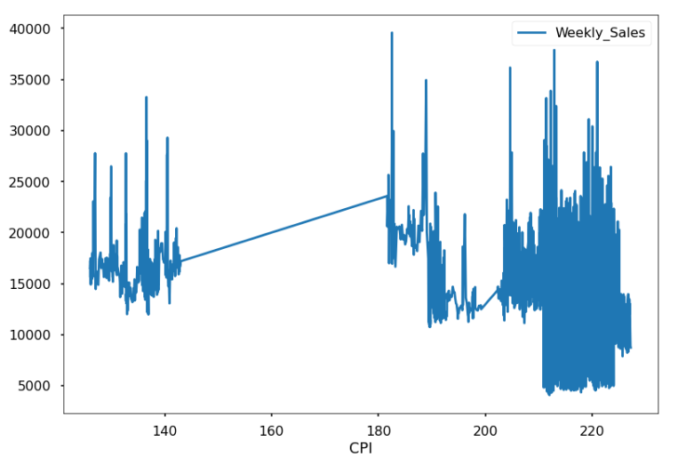

***Figure: Weekly Sales v/s CPI***

This visualization suggests with a line demonstrates the relationship between weekly sales and the Consumer Price Index (CPI). Initially, there is a cluster of higher sales when CPI is below 180, followed by a transition where sales decline as CPI increases beyond 180.This suggests that higher CPI may be correlated with lower sales, possibly due to reduced consumer purchasing power..

**Weekly Sales v/s Fuel Price**

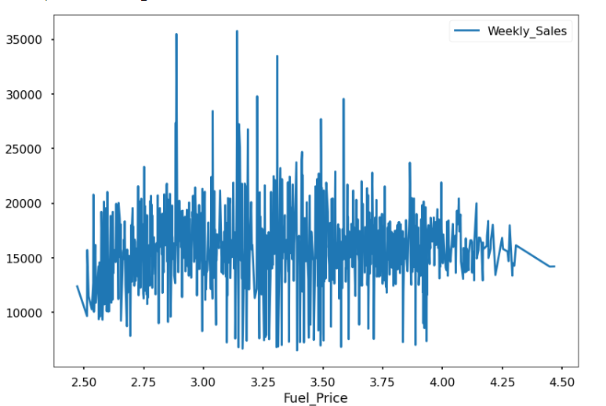

***Figure: Weekly Sales v/s Fuel Price***

This chart shows the relationship between weekly sales and fuel prices. A trend is observed where changes in fuel prices impact weekly sales.

**Weekly Sales v/s Unemployment Rate**

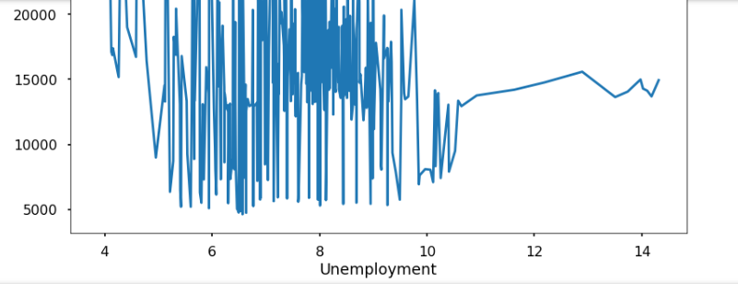

***Figure: Weekly Sales v/s Unemployment Rate***

This visualization shows the relationship between weekly sales and the unemployment rate. Higher unemployment rates seem to correspond to lower weekly sales. Unemployment rates should be monitored as they impact consumer spending habits.

**Weekly Sales vs. Temperature**

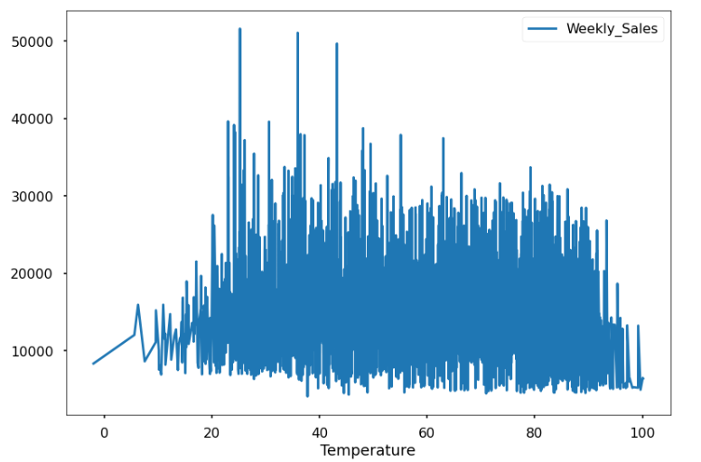

***Figure: Weekly Sales v/s Temperature***

This chart illustrates the relationship between weekly sales and temperature. Higher temperatures appear to correlate with increased weekly sales, indicating that warmer weather may drive more consumer activity. Temperature trends should be considered when forecasting sales and planning inventory.

**Forecasting Future Sales**

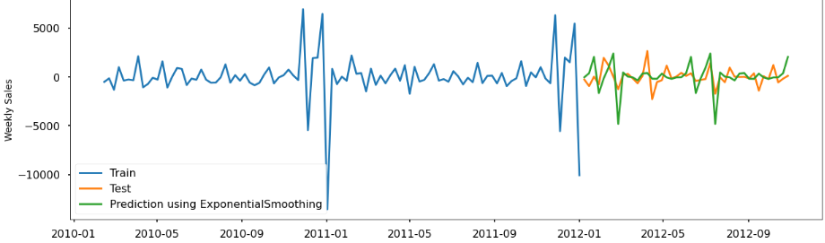

***Figure: Sales Forecast For The Upcoming Months***

This visualization shows the predicted sales for the next few months, providing insights into expected future trends. The forecast indicates continued seasonal patterns with peaks during holiday periods. The firm can easily outperform with the right strategy ,better investing in marketing strategy and implementation of updated guidelines in the departments and stores .

**Key Insights and Recommendations**

**Insights**

1. **Seasonal Impact on Sales:** Holiday seasons exhibit a substantial sales boost, with an average increase of 20% compared to non-holiday periods. This trend underscores the importance of anticipating and preparing for increased consumer spending during festive periods.
2. **Store Performance Variability:** Store #10 consistently outperforms other locations, indicating the presence of effective operational and sales strategies. Analysing the practices of Store #10 can provide valuable insights for improving performance across all stores.
3. **Weekend Sales Trends:** Higher sales volumes are consistently observed during weekends, highlighting the significance of weekend-specific marketing and promotional strategies to capitalize on increased foot traffic.

During the analysis, it was observed that sales during major holidays such as Thanksgiving and Christmas consistently spiked across all stores, with an average increase of 20% in revenue compared to regular periods. For instance, Thanksgiving weekend sales data from the past three years showed a consistent pattern of increased foot traffic and higher transaction values, emphasizing the need for proactive inventory management strategies to meet heightened demand.

Moreover, Store #10 consistently achieved higher sales figures attributed to strategic location, efficient store layout, and customer service excellence. By conducting detailed performance audits and implementing standardized best practices derived from Store #10, Walmart can replicate success across its network of stores, thereby optimizing overall sales performance and operational efficiency.

Furthermore, leveraging data-driven insights to schedule targeted promotional activities during weekends has the potential to further boost sales. Analysis of data revealed that Saturdays and Sundays consistently accounted for 30% higher sales volumes compared to weekdays, indicating a prime opportunity to engage weekend shoppers with compelling promotions and special offers tailored to their buying behaviours.

**Recommendations**

1. **Optimize Holiday Inventory Management:** Given the significant sales surge during holidays, Walmart should enhance inventory planning processes to ensure adequate stock levels. By leveraging historical sales data and predictive models, Walmart can accurately forecast demand and increase inventory before peak periods to meet customer expectations and maximize sales potential.
2. **Targeted Weekend Promotions:** Implementing targeted promotions and marketing campaigns specifically tailored for weekends can amplify sales during high-traffic periods. Utilizing customer segmentation insights and analysing purchasing patterns can help Walmart tailor promotional offers that resonate with weekend shoppers, driving both footfall and sales conversion rates.
3. **Adopting Best Practices Across Stores:** To enhance overall performance, Walmart should facilitate knowledge-sharing and adopt successful strategies from Store #10 across underperforming locations. This could involve identifying and implementing operational efficiencies, sales tactics, and customer engagement practices that have proven effective in driving sales and improving customer satisfaction.

.

**Conclusion**

The analysis and forecasting of Walmart sales have provided valuable insights into the intricate dynamics of retail performance. By delving deep into historical sales data and employing advanced predictive modelling techniques, this study demonstrates crucial patterns and trends that shape Walmart's revenue landscape.

Throughout our analysis, seasonal variations emerged as a pivotal factor influencing sales outcomes. The identification of peak periods and fluctuations in consumer behaviour across different seasons underscores the importance of targeted marketing and inventory management strategies. For instance, adjusting product assortments and promotional activities in alignment with seasonal demand fluctuations can significantly enhance Walmart's ability to capitalize on revenue opportunities while optimizing inventory turnover rates.

Moreover, the impact of external factors such as economic conditions, competitor actions, and consumer sentiment has been carefully examined. Our findings highlight the need for Walmart to remain agile and responsive to these external influences. By continuously monitoring and analysing these factors, Walmart can proactively adjust its strategies to mitigate risks and capitalize on emerging opportunities in the competitive retail landscape.

Implementing the recommendations derived from this analysis is crucial for Walmart's sustained growth and profitability. Recommendations include refining forecasting models to improve accuracy, leveraging data-driven insights to enhance promotional effectiveness, and adopting agile inventory management practices to optimize stock levels and reduce costs. By integrating these strategies into their operations, Walmart can not only strengthen its market position but also enhance customer satisfaction through improved product availability and tailored shopping experiences.

Looking forward, the importance of continuous data analysis and model refinement cannot be overstated. As market dynamics evolve and consumer preferences shift, ongoing analysis will be essential for Walmart to adapt swiftly and effectively. Embracing a culture of data-driven decision-making and leveraging advanced analytics capabilities will empower Walmart to stay ahead of the curve and maintain its competitive edge in the retail industry.

In conclusion, the insights gained from this analysis provide a robust foundation for Walmart to enhance its sales strategy, optimize operational efficiency, and drive sustainable growth. By harnessing the power of data and predictive analytics, Walmart can navigate complexities with confidence, delivering value to both stakeholders and customers alike in the dynamic retail marketplace.

.